Contents

1. Model Structure 2

1.1 Input & Output 2

1.2 Meaning of symbols 2

2. Forward Propagation 4

# Model Structure

## Input & Output

Input A single word $w_{I}$.

OutputThe words **in $w_{I}$’s context** defined by a word window of size $C$.

Format All of these words are one-hot encoded.

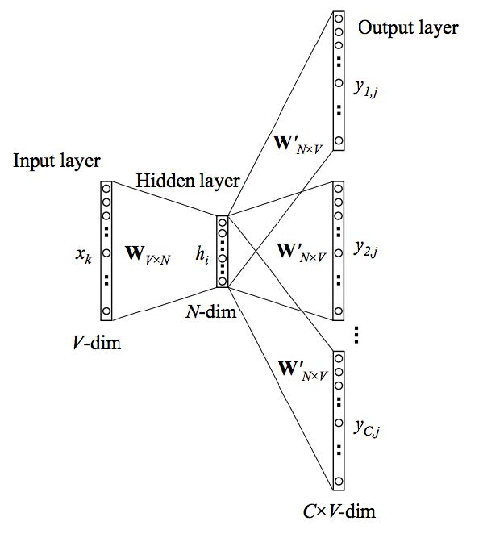

## Meaning of symbols

* $x={\left(x_{1},…,x_{k},…,x_{V}\right)}^{T}$ represents the **one-hot encoded vector** corresponding to the input word in the training instance.
* $\left\{y_{1},…,y_{C}\right\}$ are the one-hot encoded vectors corresponding to the output words in the training instance.
* $W \left(V×N\right)$ is the weight matrix between the input layer and hidden layer, whose $i$ th row represents the weights corresponding to the $i$ th word in the vocabulary. **This weight matrix is what we are interested in learning because it contains the vector encodings of all the words in our vocabulary**.
* $h={\left(h_{1},…,h_{i},…,h_{N}\right)}^{T}$ is the hidden layer.
  + Note that the exact size of $N$ is also a training parameter.
  + Since the input vector $x$ is one-hot encoded, we can observe that $h$ is simply the $k$ th row of $W$. i.e. $$h=x^{T}W=W\left(k,:\right)$$
* $W' \left(N×V\right)$ is the output matrix associated with each output vector.

# Forward Propagation